Newton & Biggin

Parish Neighbourhood Plan

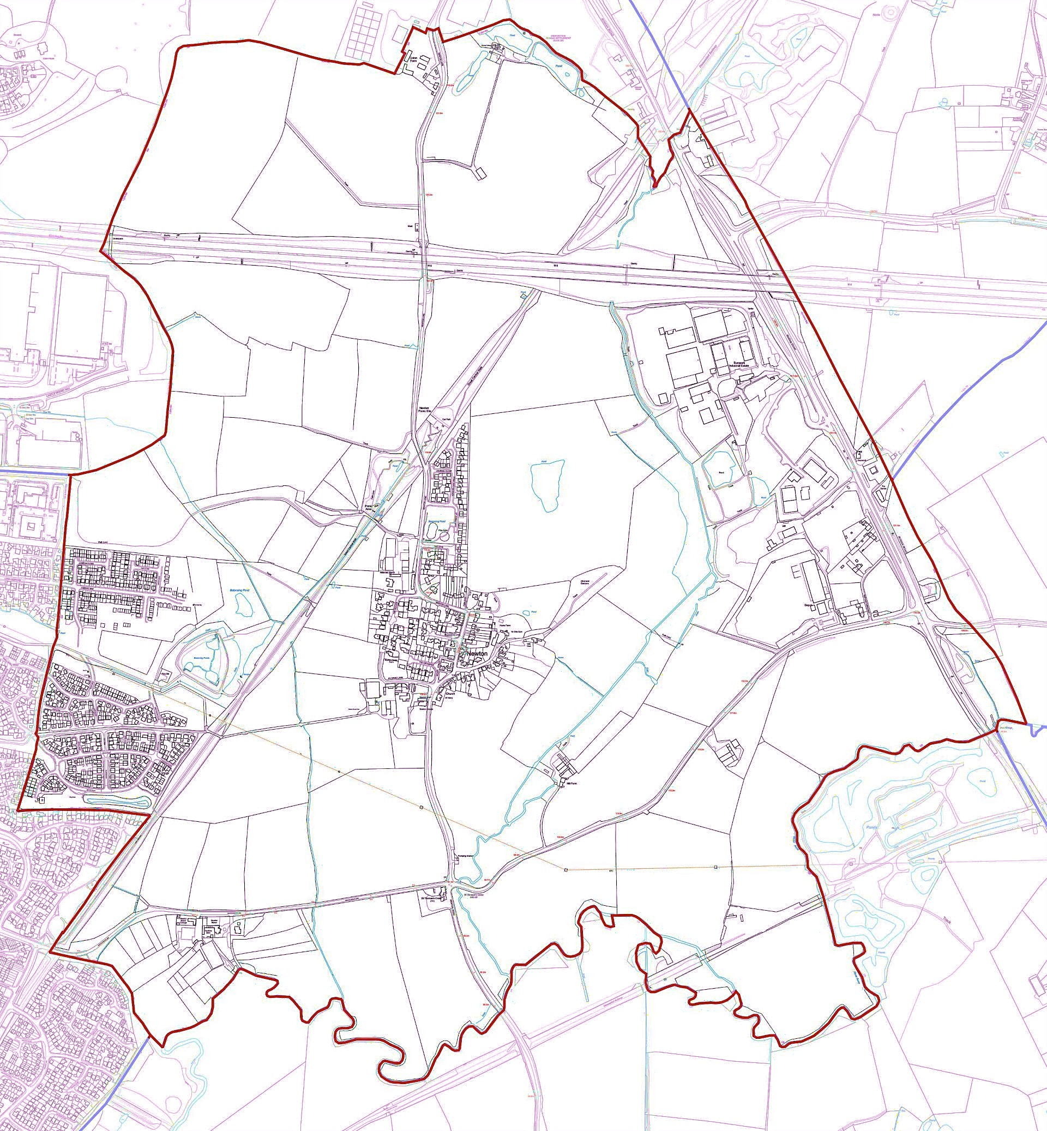

Residents Survey

Newton and Biggin Parish Council is preparing a Neighbourhood Plan for the whole Parish, which includes parts of Coton Park.

A Neighbourhood Plan gives local residents a measure of control over issues like new development and protecting open spaces and rural areas. It also provides an opportunity to identify what’s important and what needs improving.

Work is at an early stage and the results of this questionnaire will help inform the content of the Plan.

You can answer the questionnaire individually or as a household. The Neighbourhood Plan will take time to develop and there will be plenty of further opportunities to be involved.

If you would like assistance in completing this form please contact:

Andy Newnham 07745034801

Anne Davis 07939634227

|  |  |
| --- | --- |
| 1. Are you answering this questionnaire as a ... | |
| Household |  |
| Individual |  |

|  |  |
| --- | --- |
| 2. Please enter your postcode to help us understand what part of the Parish you live in. |  |

About your household

|  |  |
| --- | --- |
| 3. How would you describe your household? | |
| Family with children under 18 |  |
| Family with children over 18 living at home |  |
| Couple |  |
| Adult living with other adults |  |
| Adult living alone |  |

|  |  |
| --- | --- |
| 4. How many people in your household are … | |
| 18-40 |  |
| 41-60 |  |
| 61-80 |  |
| Over 80 |  |

|  |  |
| --- | --- |
| 5. How long have you lived in the Parish of Newton and Biggin? | |
| Less than 10 years |  |
| 10-20 years |  |
| 21-30 years |  |
| 31-40 years |  |
| 41-50 years |  |
| More than 50 years |  |

|  |  |
| --- | --- |
| 6. How would you describe your dwelling? | |
| Terraced house |  |
| Semi-detached house |  |
| Detached house |  |
| Bungalow |  |
| Flat or apartment |  |
| Other (please specify) | |

|  |  |
| --- | --- |
| 7. Please tell us how many people in your household are … | |
| Employed full-time |  |
| Employed part-time |  |
| Self-employed |  |
| Carers |  |
| Currently unemployed |  |
| Retired |  |

Our Parish – Community, Heritage and Environment

|  |  |
| --- | --- |
| 8. How do you rate Newton and Biggin Parish as a place to live or do business in? | |
| Excellent |  |
| Very Good |  |
| Good |  |
| Not Very Good |  |
| Poor |  |

|  |
| --- |
| 9. What do you value most about living in Newton and Biggin Parish? |

|  |
| --- |
| 10. What do you dislike most about living in Newton and Biggin Parish? |

|  |  |  |  |  |
| --- | --- | --- | --- | --- |
| 11. How do you rate public footpaths and bridleways in the Parish? | | | | |
| Excellent | Very Good | Good | Not Very Good | Poor |
|  |  |  |  |  |

|  |  |  |  |  |
| --- | --- | --- | --- | --- |
| 12. How do you rate public open spaces in the Parish? | | | | |
| Excellent | Very Good | Good | Not Very Good | Poor |
|  |  |  |  |  |

|  |  |  |  |  |
| --- | --- | --- | --- | --- |
| 13. How would you rate the availability of local employment? | | | | |
| Excellent | Very Good | Good | Not Very Good | Poor |
|  |  |  |  |  |

|  |  |  |  |  |
| --- | --- | --- | --- | --- |
| 14. How would you rate the availability of local activities and community groups? | | | | |
| Excellent | Very Good | Good | Not Very Good | Poor |
|  |  |  |  |  |

|  |  |  |  |  |
| --- | --- | --- | --- | --- |
| 15. How would you rate the general upkeep of the Parish? | | | | |
| Excellent | Very Good | Good | Not Very Good | Poor |
|  |  |  |  |  |

|  |  |  |  |
| --- | --- | --- | --- |
| 16. Do you, or a member of your household, use the following … | | | |
|  | Often | Sometimes | Never |
| Byways, Bridleways and Footpaths in the Parish |  |  |  |
| The Good Shepherd Church, Newton |  |  |  |
| Local schools |  |  |  |
| Stag and Pheasant pub |  |  |  |
| St Thomas Cross pub |  |  |  |
| Newton Village play area |  |  |  |
| Betony Road play area |  |  |  |
| Five Arches Wildlife Area/Great Central Way |  |  |  |
| Newton Memorial Hall (Village Hall) |  |  |  |
| Buses from Coton |  |  |  |
| Buses from Newton |  |  |  |
| Allotments |  |  |  |

|  |  |  |  |
| --- | --- | --- | --- |
| 17. How important are the following to your household? | | | |
|  | Very important | Somewhat important | Not so important |
| Protection of Countryside Rights of Way |  |  |  |
| Protection of ancient fields, hedgerows and woodlands |  |  |  |
| Protection of wildlife and habitat |  |  |  |
| Mobile reception |  |  |  |
| Broadband provision |  |  |  |
| Allotments |  |  |  |
| Rubbish and dog waste bins |  |  |  |
| Street lighting |  |  |  |
| Fixed benches and planters in the Parish |  |  |  |
| Good Shepherd Church, Newton |  |  |  |
| Local schools |  |  |  |
| Stag and Pheasant pub |  |  |  |
| St Thomas Cross pub |  |  |  |
| Newton Village play area |  |  |  |
| Betony Road play area |  |  |  |
| Five Arches Wildlife Area/Great Central Way |  |  |  |
| Newton Memorial Hall (Village Hall) |  |  |  |
| Buses from Coton |  |  |  |
| Buses from Newton |  |  |  |

|  |
| --- |
| 18. Are there any facilities above that should be improved or expanded? |

|  |
| --- |
| 19. Please add any other services or amenities you may like to see in the Parish |

Education

|  |  |  |  |
| --- | --- | --- | --- |
| 20. How well do you think the Parish is served with access to educational facilities? | | | |
|  | Well served | Adequate | Not well served |
| Pre School |  |  |  |
| Primary School |  |  |  |
| Secondary School |  |  |  |
| Adult learning |  |  |  |

Transport and Getting Around

|  |  |
| --- | --- |
| 21. How many vehicles are in your household? | |
| None |  |
| 1 |  |
| 2 |  |
| 3 |  |
| 4 or more |  |

|  |  |
| --- | --- |
| 22. How many of these vehicles are parked within the property's boundary? | |
| None |  |
| 1 |  |
| 2 |  |
| 3 |  |
| 4 or more |  |

|  |  |  |  |  |
| --- | --- | --- | --- | --- |
| 23. Thinking about things that could be done to encourage road safety in the Parish, bearing in mind future traffic growth, which of the following road calming measures would be important? | | | | |
|  | Very important | Important | Not important | No strong opinion |
| Speed restrictions |  |  |  |  |
| Where? | | | | |
| Junction improvements |  |  |  |  |
| Where? | | | | |

|  |  |
| --- | --- |
| 24. Thinking about accessing community facilities and the countryside, both now and into the future, would you like to see new cycle routes established? | |
| Yes |  |
| No |  |
| If so, where (including start and end points) | |

|  |
| --- |
| 25. Do you have any further comments about transport, parking or safety? |

Your concerns

|  |  |  |  |
| --- | --- | --- | --- |
| 26. How concerned are you about the below issues? | | | |
|  | Very concerned | Concerned | Not concerned |
| Burglary |  |  |  |
| Vandalism |  |  |  |
| Vehicle crime |  |  |  |
| Anti-social behaviour |  |  |  |
| Litter |  |  |  |
| Fly-tipping |  |  |  |
| Dog fouling |  |  |  |
| Policing |  |  |  |
| Inconsiderate parking |  |  |  |
| Upkeep of residents buildings and gardens |  |  |  |
| Noise levels |  |  |  |
| Anything else? | | | |

Employers and employment

|  |  |
| --- | --- |
| 27. Are you employed by a local business (within 5 miles of the Parish)? | |
| Yes |  |
| No |  |

|  |  |
| --- | --- |
| 28. Do you operate a business from within the Parish? | |
| Yes |  |
| No |  |

|  |  |
| --- | --- |
| 29. Does the current internet provision in the Parish meet your business needs (including working from home)? | |
| Yes |  |
| No |  |

|  |  |
| --- | --- |
| 30. Would you welcome new businesses to the Parish? | |
| Yes |  |
| No |  |

|  |
| --- |
| 31. If you answered yes, what type of businesses would you like to see and where would they be situated? |

|  |
| --- |
| 32. Please add any additional comments on business and employment. |

Housing

|  |  |
| --- | --- |
| 33. Should the Neighbourhood Plan identify a small site or sites to meet an identified local housing need? | |
| Yes |  |
| No |  |
| If yes, would you like to provide details of any sites you feel may be suitable for development within the Parish | |

|  |  |  |  |  |
| --- | --- | --- | --- | --- |
| 34. How important do you feel new housing development is in the Parish with regards to … | | | | |
|  | Very important | Important | Not important | No strong opinion |
| To meet general housing need in the Parish |  |  |  |  |
| To provide affordable housing To enable local young people to move to, or remain living in the Parish |  |  |  |  |
| To enable older people to move into more suitable accommodation for their needs (e.g. downsizing) |  |  |  |  |
| To meet the needs of those with additional needs |  |  |  |  |
| Other (please specify and provide rating of importance) |  |  |  |  |

|  |  |  |  |
| --- | --- | --- | --- |
| 35. Have you, or any member of your family (even if they don’t live with you now), recently had a problem finding suitable living accommodation in the Parish? | | | |
| Yes, currently | Yes, in the last year | No, but I anticipate this being a problem | No |
|  |  |  |  |

The current housing mix in the Parish (from 2021) is as follows:

|  |  |  |
| --- | --- | --- |
| Detached | 271 | 45.5% |
| Semi-detached | 218 | 36.6% |
| Terraced | 86 | 14.4% |

|  |  |  |  |
| --- | --- | --- | --- |
| 36. What do you think of the current mix of housing in the Parish? | | | |
|  | Too little | Adequate | Too many |
| Flats |  |  |  |
| Bungalows |  |  |  |
| Small houses (1-2 bedrooms) |  |  |  |
| Family housing (3-4 bedrooms) |  |  |  |
| Large houses (4+ bedrooms) |  |  |  |
| Private rented housing |  |  |  |
| Retirement / sheltered housing |  |  |  |
| Housing association/local authority housing |  |  |  |

|  |  |  |  |  |  |
| --- | --- | --- | --- | --- | --- |
| 37. Regarding design of houses to be developed in the Parish, what style do you think would fit best? Please rate each from 1 (strongly disagree) to 5 (strongly agree) | | | | | |
|  | 1 | 2 | 3 | 4 | 5 |
| Traditional style, traditional materials |  |  |  |  |  |
| Modern design, traditional materials |  |  |  |  |  |
| Traditional style, modern materials |  |  |  |  |  |
| Modern design, modern materials |  |  |  |  |  |
| Unique design and/or materials |  |  |  |  |  |

|  |  |
| --- | --- |
| 38. Should all new development meet net zero requirements? (i.e. remove at least as much greenhouse gas as it creates) | |
| Yes |  |
| No |  |

|  |  |
| --- | --- |
| 39. Should there be a minimum tree canopy policy (amount of trees planted per development) for new developments? | |
| Yes |  |
| No |  |

|  |
| --- |
| 40. Are there any other climate change policies that we should be considering? |

Thank you for completing this survey

All responses will be used solely for preparing this Neighbourhood Plan. Your participation in this questionnaire, together with your individual responses to the questions asked, will be kept confidential and no-one will be identifiable in any published results.